# Methods for the validation of model-based flows allocated to the road network: a case study of cycling

## Abstract

To do:

* Polish the text and add references in the review of methods for model validation.
* Accident data analysis
* Generate PCT estimates for London.
* Get James Howarth to compare with Strava data (sounding out – 2nd paper?)
* Compare with Bike Citizens data (illustrative example of e.g. Hackney)
* Write conclusions
* Submit!

## Introduction

Modelling is an important component of the transport planner’s toolkit, providing insight into transport systems that would otherwise be impossible (Lacono et al. 2007). Models facilitate the estimation of current and future scenarios of movement patterns (Schlesinger et al. 1979); visualisation of key patterns which may otherwise be invisible (Keim, 2001) and evaluation of alternative investment options in 'model experiments' to help decide on the best course of action, e.g. regarding where new bus routes should go (Wirasinghe and Vandebona 2011). Modelling and the communication of model results can thus be vital for making decisions about new infrastructure. Modelling has become so central to transport planning decision making that there have been calls to reassess the role of modelling in the sector. A recent report, for example, identifies instances of misuse in transport modelling and proposes greater levels of transparency and public engagement in the model development process to tackle this issue (Hollander 2015).

A critical but often overlooked component influencing the amount of trust we should have in transport models is validation. There is a strong argument suggesting that all transport models used for policy evaluation should be verified and validated to test the reliability their results, for example by comparing the model’s output under a specific scenario against real-world data (Anderson and Woessner, 1992). Yet this is rarely done, especially in relation to models of the future. This can lead to remarkable failures in the transport decision making process. In one infamous scheme, the Thames Gateway Bridge, the lack of validation in the underlying model was responsible for an entire scheme being scrapped (Hollander 2015).

This paper uses the example of modelling the rate of cycling on the transport network to illustrate methods for rout-allocated model validation. The aim is to demonstrate and compare different geographical methods and datasets for evaluating flow estimates. It is expected that the demonstration of methods and findings will be useful in future research. Although the methods were developed for a specific purpose and mode – the evaluation of the Propensity to Cycle Tool (PCT) – they are applicable to any transport or agent-based model that generates estimates of travel flow rates on the route network.

The paper is structured as follows: the next section provides a brief description of the PCT in the context of route-allocated transport models. This provides a motivation for the subsequent overview of model validation in the transport modelling literature. Because of the close link between datasets and methods for flow estimate validation, the subsequent section describes the input data and methods together. Datasets derived from screen-line counts, CCTV footage, road traffic casualty records and passively collected ‘volunteered geographical information’ (VGI) are described in turn, alongside the methods needed for them to be compared with the PCT model results.

# The Propensity to Cycle Tool

There are many models using various techniques to study where people choose to cycle to work and for leisure as well as studies which collect data via GPS units and analyse the data to find the most popular routes. (Dill and Carr, 2003; Krizek *et al.*, 2007; Menghini *et al.*, 2010; Broach *et al.*, 2012; Ehrgott *et al.*, 2012; Larsen *et al.*, 2013). However at the time of writing there are not any models which aim to predict the amount of cycling in an area as well as the possible response to cycling becoming more favourable amongst the population. Therefore the PCT is aiming to become a niche tool to help planners.

There are some novel approaches in the literature which study the most where spending will have the most effective spending on the road network (Larsen *et al.*, 2013). Larsen *et al.* (2013) used a Geographical Information System (GIS) approach to assess the cycling network in Montreal, using a form of Multiple Criteria Analysis (MCA) with datasets surrounding Origin-Destination data (OD) for cyclists, car trips, suggested cycling routes from the public, and accident data they evaluated the current system and proposed suitable modifications.

The UK is currently facing a large increase in the number of people choosing to travel by bicycle as there are now 600 million more miles ridden per year in comparison to 1993 (Hollingworth *et al.*, 2015). This rise in cycling has resulted in a rise in incidents, Keep (2013) discovered that there was 32% increase in people being killed or seriously injured while cycling between 2002 levels and 2012 levels. Figure 1 shows the number of people killed or seriously injured over a 5 year period in Leeds, there has been an increasing number of incidents possibly due to the increased levels of cycling (Leeds Data Mill, 2015).

Recent studies into cycling infrastructure prove that spending on infrastructure helps to reduce the amount of people killed or seriously injured while cycling as well as encouraging people to take up cycling (Reynolds *et al.*, 2009; Broach *et al.*, 2012). Unfortunately building cycling infrastructure is not cheap, schemes such as city connected, an infrastructure project linking Bradford and Leeds, is set to cost c£30m while a north-south cycle superhighway through London is costing £160m. Therefore tools such as the PCT can help improve the location of cycling infrastructure projects allowing them to have the most effective cost-benefit scenario.

*Figure 1 the number of people killed or seriously injured while cycling in Leeds (Leeds Data Mill, 2015)*

# Review of methods to validate flow estimates

…

Methods to validate flow estimates have been evolving overtime either by the technique that is used or the data used to validate the model. Possibly the most use method is to use on-street counts of flows (Donnelly et al., 2012; Munuzuri et al., 2012, 2004). However these methods are questionable with as Donnelly et al. (2012) highlights, indicating that the quality and quantity of counts makes the validation data poor and therefore conclusions on the validity of the model are inconclusive. Methods to improve the data collection of on street counts have been improving with the introduction of auto recognition software (Khan and Raksuntorn, 2001). Auto recognition software allows for continuous data capture of cyclists, therefore improving the quality and quantity issues associated with manual on-street data capture. Camera detection technology can also improve the quantity of counts to provide a more holistic overview of the transport network.

Using Volunteered Geographic Information (VGI) from GPS devices and smart phones real world data can be used to help validate models (Strauss et al., 2015). While the use of such systems does not capture 100% of cyclists it can be inferred to be a percentage of all cyclists and therefore correlate to the model data.

# Methods

### Screenline

Measuring daily flows of traffic is usually carried out using the screenline method (Nicolaisen and Driscoll, 2014). Screenline counts are usually carried out manually via pen and paper records, therefore opening them up to human error when recording data. Recently there has been an advance in computing that allows the recognition of shapes; this technology is now being used to record the number of cyclists passing a point. The added advantage of this automation is that data can be collected for every hour of everyday, whereas previously manual data collection could only be carried for as long as the user was willing to pay to record data. Therefore collecting data manually would lead to a sub-optimal dataset.

*Figure 2 the location of each screenline used to validate the PCT*

In this paper the screenline data was collected in April and May 2014. To try to make the data as uniform as possible counts were only recorded on days inside school term time and when the weather was not adverse. On the day of collection data was collected over a 12 hour period (7am – 7pm). Figure 2 shows the distribution of the survey points.

### Auto-recognition camera data

Technology can now be used to help provide higher resolution count data because cameras can now detect the shape of a cyclist. Data can be recorded for the whole day over the whole year, whereas manual methods such as the screenline method only offer data for part of the year and day.

The data collected in this study has been collected from the locations seen in figure 3. The cameras detect the number of cyclists on an hourly rate as well as the direction that they are heading. The data is freely available on the Leeds Data Mill website <http://leedsdatamill.org/dataset/leeds-annual-cycle-growth->.



*Figure 3 the location of each camera used to validate the PCT*

# Results

## Screenline

Figures 4 and 5 display the data for the screenline counts and the PCT model prediction. Figure 4 shows that the average daily number of cyclists for the screenline data is much higher than the PCT model. However the PCT model only accounts for commute cyclists, therefore this trend is too be expected.

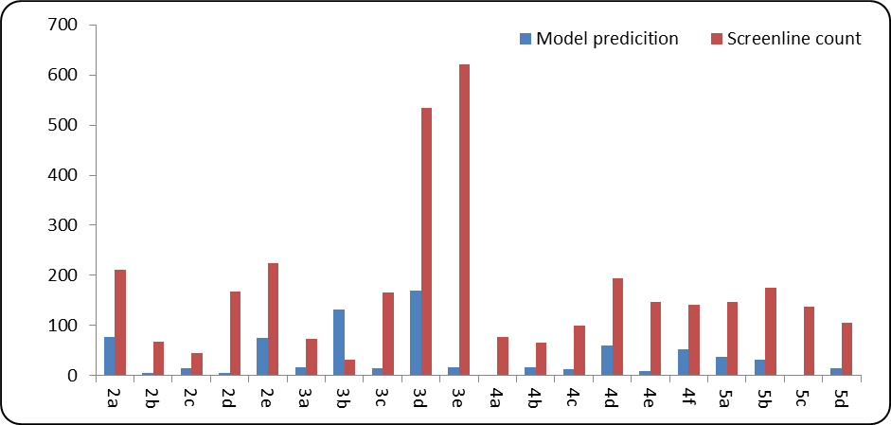

*Figure 4 the screenline location daily average number of cyclists and the model prediction*

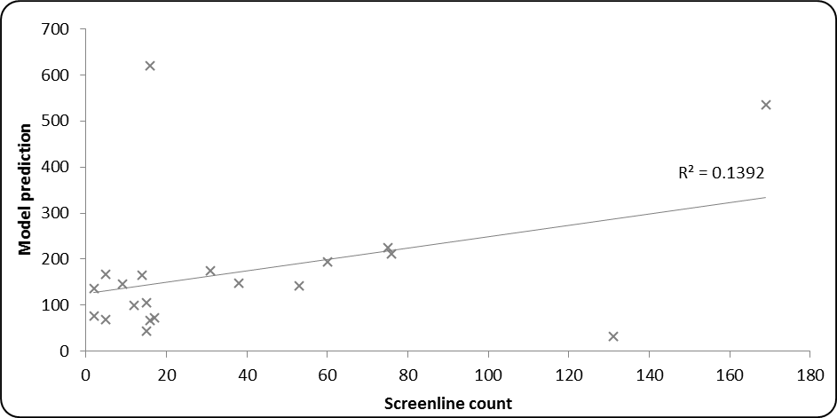

*Figure 5 the relationship between the model prediction and the real world data*

### Auto-recognition camera data

Fig. 6 illustrates that it is important to take trends in cycling at the local level into account. Note that CCTV footage from point 90810 indicates rapid year-on-year, whereas there are steady and even declining trends for the other locations. Ideally the results should be fitted for the same year of data collection for which the model is calibrated.

Figure 7

*Figure 6 the camera count daily average for each year and the model output*

*Figure 7 the relationship between camera count daily average for each year and the model output*

Discussion and conclusions

* Main findings of the validation
* Findings from each validation technique
  + Include strength of technique and weakness
* Introduce potential data sources such as strava and discuss the pros and cons of such data

## References

Anderson, M. P. & Woessner, W. W. 1992. The role of the postaudit in model validaiton. *Advances in Water Resources,* 15**,** 16-173.

Broach, J., Dill, J. & Gliebe, J. 2012. Where do cyclists ride? A route choice model developed with revealed preference GPS data. *Transportation Research Part A: Policy and Practice,* 46**,** 1730-1740.

Dill, J. & Carr, T. 2003. Bicycle Communting and Facilities in Major U.S. Cities. *Transportation Research Record,* 1828**,** 116-123.

Ehrgott, M., Wang, J. Y. T., Raith, A. & van Houtte, C. 2012. A bi-objective cyclist route choice model. *Transportation Research Part A: Policy and Practice,* 46**,** 652-663.

Hollingworth, M. A., Harper, A. J. L. & Hamer, M. 2015. Risk factors for cycling accident related injury: The UK Cycling for Health Survey. *Journal of Transport & Health,* 2**,** 189-194.

Krizek, K. J., El-Geneidy, A. & Thompson, K. 2007. A detailed analysis of how an urban trail system affects cyclists' travel. *Transportation,* 34**,** 611-624.

Larsen, J., Patterson, Z. & El-Geneidy, A. 2013. Build It. But Where? The Use of Geographic Information Systems in Identifying Locations for New Cycling Infrastructure. *International Journal of Sustainable Transportation,* 7**,** 299-317.

Menghini, G., Carrasco, N., Schüssler, N. & Axhausen, K. W. 2010. Route choice of cyclists in Zurich. *Transportation Research Part A: Policy and Practice,* 44**,** 754-765.

Nicolaisen, M. S. & Driscoll, P. A. 2014. Ex-PostEvaluations of Demand Forecast Accuracy: A Literature Review. *Transport Reviews,* 34**,** 540-557.

Reynolds, C. C., Harris, M. A., Teschke, K., Cripton, P. A. & Winters, M. 2009. The impact of transportation infrastructure on bicycling injuries and crashes: a review of the literature. *Environ Health,* 8**,** 47.

#### Leeds Data Mill (2015). *Cycling accidents in Leeds | ODI Leeds | Publishers*. [online] Available at: http://leedsdatamill.org/dataset/cycling-accidents-in-leeds [Accessed 10 Nov. 2015].